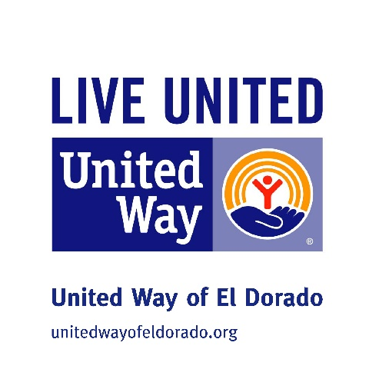
How It Began…. 54 years ago!
United Way of El Dorado has been able to contribute to the quality of life in El Dorado and Butler County since 1962 when it was the Community Chest. Through the hard work and commitment of volunteers like you. You join the ranks of some of the community’s most respected business leaders as you help continue our tradition of caring. We want to change our focus just a bit, so we are more effective in our community and our impact is greater than ever before. We’re focusing on the tree building blocks to a quality life of EDUCATION, INCOME STABILITY and HEALTH. By focusing our efforts in these three categories we can see where needs are being met and where we need to focus our attention. We can’t do this without you! United Way of El Dorado offers resources and programs to help meet the needs within our community.
Our Perspective Today….
- Listen to the community
- identify pressing issues and priorities
- Develop change strategies
- Define expected outcomes
- Activate resources to support this work

United Way of El Dorado community Initiatives/programs

- 2-1-1 is the number to call to reach the Information and Referral Center for United Way of El Dorado. Phones are answered by trained professionals 24 hours a day, 7 days a week, 365 days a year. Calls are free. Need utility assistance? Need to know how to dispose of paint? Need to know about day care? 200 calls in Butler County have been made in the last 6 months.
Free Tax Preparation:
Method 1: File on your own!
If you are comfortable using a computer, you can access the United Way supported program online at unitedway.org/myfreetaxes Follow the prompts to be guided through the process at your own pace. To qualify for free filing, adjusted gross income in 2016 must be below $62,000.
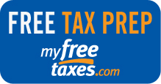
Method 2: Visit the Free Tax Clinic
Schedule an appointment with an IRS-certified volunteer tax preparer at your local VITA site who can work directly with you to file your tax returns. The Total Action for Progress tax clinic is located at 116 W. Pine Street, and reservations can be made starting January 12th by calling (316-321-6200 To qualify for assistance, adjusted gross income in 2016 must be below $54,000. The tax clinic will be open February 1st, 2016

Prescription Drug Discount Card:
Familywise prescription drug cards are available at the United Way to be used at participating pharmacies where a 42% reduction can be used. So far over $9,245 and 147 has been saved by residents in our community on prescriptions! Cards are available at the United Way oﬃce.
Free Flu shots will be offered through our partnership with familywise.
When: September 24th at 9:00 a.m. Central and Main, we are partnering up with the Elks to offer free vision screenings and we will offer the flu shots. Look for the Elks trailer and the United Way sign!
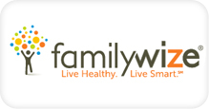

OUR FOCUSES

Impact in Education
Why Invest in Education?
Today, young Americans are less likely to earn a diploma than young people in other industrialized countries. Missing this milestone can have detrimental effects. High school graduation is the single most powerful predictor of whether a young person coming from generations of poverty will break the cycle. EL Dorado education statistics affirm that this issue needs to be a local priority. 58.43% of students are living economically disadvantaged in USD 490. This is why United Way is investing in strategies that increase access to affordable, quality childcare; increase public awareness and support for investing early. Equip students to read and comprehend by third grade; connect students with help they need to stay in school; and equip parents to help children be ready for school and to succeed in school.

Impact in Income
Why Invest in Income?
Today, the lack of resources to meet basic needs prompts close to 200 calls a month to 2-1-1 from all over Butler County. The cycle of increasing debt to keep up with the rising cost of living has left many families living paycheck to paycheck. As a result, families are more vulnerable to crisis, and in the long term, they have a very limited ability to save for advanced education, a home, reliable transportation or retirement. This limits the economic potential of both the family and the communities in which they live. This is why United Way is investing in strategies that provide access to employment and other opportunities; increase ability to manage personal finances effectively; and help people in crisis meet their basic needs and move them to self-sufficiency.

Impact in Health
Why Invest in Health?
Today, many El Dorado residents do not have access to primary health care — so important to preventing or treating illness before it becomes more serious. In a study conducted by the Centers for Disease Control (CDC), a large percentage of people in the area were identified as obese, making them more susceptible to diabetes, heart disease and other issues. Every day that it was open it was utilized by individuals and families seeking assistance. A safe and healthy home environment, access to health services and preventative healthcare starting early in childhood, avoiding risky behaviors, as well as knowledge about healthy eating and physical activity all contribute to achieving optimum health for individuals and our community. This is why United Way is investing in strategies that pursue and promote healthy living and lifestyle; provide access to affordable healthcare services and provide crisis and intervention services needed for health and wellness.
1 in 5 Kansas children are food insecure. 54% of students are on free and reduced lunches. El Dorado ranks one of the highest in Kansas. As of August 22, 2016, 22 new households were seeking assistance from the Butler Homeless Initiative. The Cold shelter was open in March of 2016 and 2 women, 8 men and one family received shelter. This is just one month!

